|  |  |
| --- | --- |
| Course Name | ITD 2313 – Script Programming |
| Instructor | Put instruction name here |
| Student Name | Put student name here |
| Due date | Put assignment due date here |
| Grade | Put grade earned here |
| Grading Comments | Put instructor comments here |

### Page 55

1. The first example code is the help line near the top of the page.
2. The second example code set is in the the math module subsection about 3/4 down on the page.  You need to do this step before doing any of the code examples on page 56

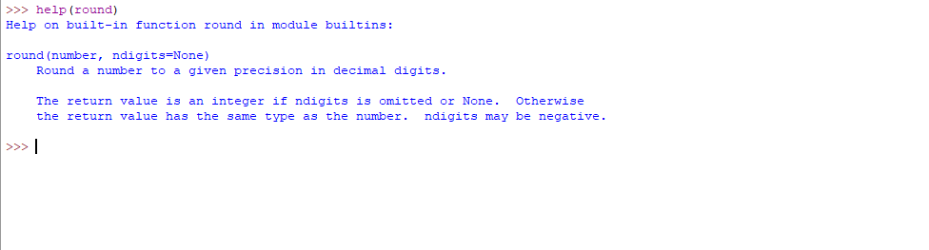

### Page 56

1. The first code example is near the top and has you working a little with the math module
2. The second code set is a little below the first and again utilizing the help feature but this time with a math module function
3. The third code example for the page shows the import functionality with just a select few items
4. The last item on the page shows you how to import a Python program as a module.  You will need to have downloaded the file in the resources for the week section of the class for this one.

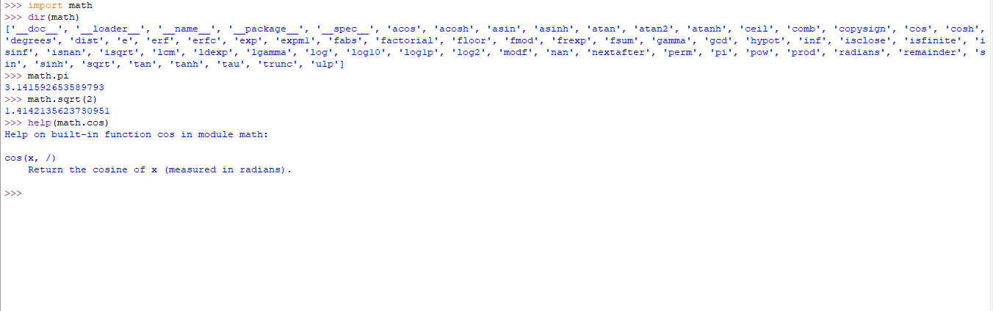

**Page 57**

1. The last item on page 55 showed you how to import a python program and the first item on this page shows you how to use help with that imported item.

